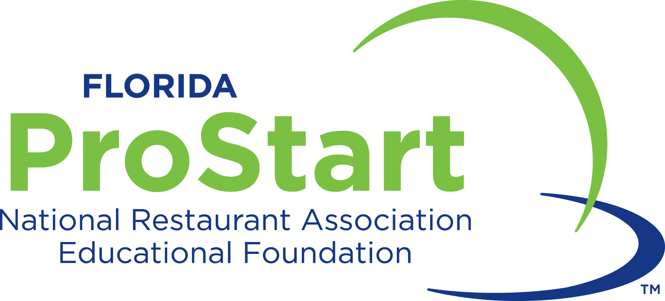

Participant Waiver and Release

I (we) understand that I (we) hold Florida Restaurant & Lodging Association Educational Foundation (FRLAEF) and any affiliated entity, including its officers, agents and employees harmless from any and all liability or claims, which may arise out of or in connection with my child's participation in the Florida ProStart Culinary Team Competitions and related and surrounding activities, including but not limited to mandatory or optional events or tours (collectively “the event”). I (we) fully understand that participants are to abide by all rules and regulations governing conduct during the trip. Any violation of these rules and regulations may result in that individual being sent home at the expense of his/her own and/or parent/guardian.

Misconduct, which includes, but is not limited, to alcohol or drug use (including cigarettes), at “the event”, during competition or in activities or locations related to or surrounding “the event”, may disqualify a participant or the participant's team from awards or further participation. Should any misconduct come to FRLAEF’s attention, the matter will be investigated, as FRLAEF deems appropriate. Any decision and sanction as to appropriate action due to misconduct is at the sole discretion of FRLAEF, and is final. By entering into the contest, the student and the team accept this requirement as well as all other conditions of the program.

I (we) hereby consent that FRLAEF, its representatives, successors or assigns, shall have the right to publish or use any photographs, movie films, video tapes, digital images and/or sound recordings, submitted text or any part thereof, they have taken or made of me (student) on this date or in which I (student) may have been included, for publicity, advertising, Internet usage or any other lawful purpose in conjunction with my (student) own or a fictitious name or image, or in reproductions thereof in color.

I (we) hereby waive all claims for any compensation for use or for damages.

I (we) hereby waive any right that I (we) may have to inspect and/or approve the finished product or the use to which it may be applied.

I (we) hereby warrant that I (we) have every right to contract in my (student) own name in the above regard. I (we) state further that I (we) have read the above authorization and release, prior to its execution, and that I (we) am fully familiar with the contents thereof.

This form must be completed and signed before students are eligible to participate in the Florida ProStart® Culinary Team Competitions. I (we) have read, understand and agree to comply with the information in this document.

Name of Student (print)
High School Name
Current Grade Level
Home Address
City, State, Zip
Student Email |  | Telephone
Emergency Contact |  | Telephone
After you graduate, do you plan to study restaurant management or culinary arts? Yes No
Do you plan to pursue a career in the restaurant & food service industry? Yes No
Student Signature |  | Date
Parent/Guardian Name (print)
Parent or Guardian Signature |  | Date

Completed, signed Participant Waivers must be collected by educators and send to the FRLAEF.
Students without a waiver will not be allowed to participate.

