21st Annual ProStart Culinary Team
Competitions

UCF’S ROSEN COLLEGE
Management Competition




UCF’S ROSEN COLLEGE

Management Competition

saturDAY, mARCH 5 + sunDAY, mARCH 6, 2022

Description
Participating teams will demonstrate their knowledge of the restaurant and foodservice industry by developing a new restaurant concept and presenting it to a panel of judges at a simulated business exposition. The teams will also submit a written proposal for review and will present their concepts to various groups of judges through verbal presentations, question-and-answer segments and posters.

The competition is designed for students to present their restaurant concept to judges as they rotate throughout the competition. The students will present their concept to the judges in an enclosed meeting room. In the meeting room, students will have a copy of their written proposal and 2 (two) 24 x 36-inch posters.

General Rules
- Team will send all required paperwork to the Florida Restaurant & Lodging Association Educational Foundation (FRLAEF) no later than February 4, 2022. (If necessary, you will be able to make changes after you turn in your information.) If all required information is not received by 5:00 pm on February 4, the first team on the waiting list will replace your team in the competition.
- Only one (1) team per school may compete in the Management Competition. The team will consist of two (2) to four (4) team members and one (1) Team Manager for a total of five (5) team members. The team must consist of students from the same school or career center. If the students are not from the same school or career center, the team will be disqualified.
- A student may compete in only one (1) competition.
- All participating students must be juniors or seniors in high school and may only compete a total of two years. Participating students must be enrolled in a Premier or Full ProStart Program using the ProStart® curriculum during the 2021 – 2022 school year. The program must be a confirmed ProStart program as recognized by the National Restaurant Association Educational Foundation.
- Competition schedules will be distributed in advance of the event. The schedule will include assigned start and finish times for all competition segments. All schedules are subject to change without notice but changes will be communicated out with as much advance notice as possible.

Uniform
Each team is required to dress in uniform during all portions of the competition. The uniform consists of solid color, ¾ sleeve or long sleeve, collared dress shirts, dress pants or skirts and professional footwear suitable for a business meeting, with heel height no more than 3 inches. Neckwear of any sort (i.e., necktie, bowtie, bolo tie, bandana, etc.) should not be worn. Only ProStart or sponsor logos are allowed on the uniform shirts. No other logos are permitted, including concept logos. All team members should wear the same style of shirt, and pants should be worn appropriately and professionally (not sagging, etc.) Khaki pants may be worn. Jeans are not permitted. The team’s uniform should reflect a professional event, not their concept, as concept logos are prohibited on their uniforms.

Role of the optional Team Manager
- The Team Manager is an important asset to the team who also serves as the alternate.
  - The Team Manager is not permitted on the competition floor and must stay in the designated Team Manager seating area.
  - The Team Manager may be introduced and shake hands at the end of the feedback session.
  - The Team Manager may not communicate with the other team members, or their educator, to collaborate on answers during the competition period.
- In the event a team member is unable to compete, the team should notify the lead official. Only with approval from the lead official, the Team Manager may permanently replace that team member.
- The replaced member, or any other competitor, may not return, step in for or replace the team manager. If the team manager replaces a team member, s/he must stay for the duration of the competition.
- The replaced member should leave the competition area. At the discretion of the educator, replaced members may leave the event or may stay and watch as an observer. The replaced member is not permitted to communicate with their team from the moment they are replaced until after feedback.

Preparation for Management Competition
- Mentors and educators may assist teams in preparation for the competition; however, they may not prepare the written proposal or posters. Their expertise is limited to acting as a sounding board for concept development.
- The team’s work must be unique and not built off previously submitted work. Submitting any work, or parts of work, that was previously submitted will result in immediate disqualification.
- The Management team may collaborate with the Culinary team on the menu and recipe items, including recipe development, costing, pricing and photography.
- Required templates can be found on our competition webpage: https://frla.org/2022-prostart-competition/
- Requirements
  - Restaurant Concept must be in ProStartville. Exhibit A contains the city’s description including demographics and local points of interest.
  - Students will select 1 of the 4 provided restaurant space scenarios provided in Exhibit C.

Team Check-in

An open check-in period will take place on day, Saturday, March 5, 2022, from 9:00 AM – 12:00 PM at the Rosen Plaza Hotel. Team check-in will close at 12:00 PM. Teams should schedule their travel, so they arrive in Orlando to allow sufficient time to check-in their materials by 12:00 PM on Saturday, March 5. Teams that have not checked in their materials by 12:00 PM on Saturday, March 5, 2022 will be disqualified.

At check-in, teams will submit the following items:

Fifteen (15) copies of the written proposal

Menu and Costing information in a separate manila folder

Two (2) 24 x 36-inch posters
- One copy of the written proposal will not be returned to teams at the conclusion of the competition and may be used by FRLAEF for promotional, educational, research or other purposes.

WRITTEN PROPOSAL

General Guidelines for the Written Proposal (See Exhibit B for Outline and Checklist)

Typed, 12 point, Times New Roman or Arial font, 1-inch margins.

Printed on white paper, single-sided and stapled (NOT in a folder, spiral bound, 3-ring binder, etc.).

The front cover must include only the following information: team number, names of team members, and concept name, concept logo and year. Style and font of the cover page should match the contents.

All 15 copies must be identical.

In addition to the Written Proposal, teams must prepare one additional copy of the sample menu, the recipes, photographs, costing and menu pricing worksheets in a standard manila colored folder. The team’s number must be listed on the front of this folder.

WRITTEN PROPOSAL CONTENTS
- Restaurant Concept Description (2 pages maximum): The following information must be included in the description:
  - Type of establishment
  - Purpose and impact
  - Meals served (breakfast, lunch, dinner, etc.)
  - Hours of operation
  - Type of cuisine served
  - Target market within the fictional city of ProStartville (defining characteristics, demographics, business/leisure, etc.)
- Floorplan and Selected Restaurant Space Scenario (1 page maximum): FRLAEF will provide 4 restaurant space scenarios to choose from. Students must use one of the four scenarios provided to create a unique floorplan. (See Exhibit C for Restaurant Space Scenario Options.) A basic floorplan of the restaurant’s layout (front-of-the-house and back-of-the-house) must be provided. The floorplan may be handwritten or electronically diagrammed. Students are encouraged to make it as much to scale as possible; however, the floorplan will not be judged on scale and proportions, but on how well it conveys the restaurant’s flow and the inclusion of features necessary to run a restaurant. (See Exhibit D for Sample Floorplan.)
- Interior and Décor (2 pages maximum): Teams will prepare a description of interior and décor for their concept. This may include photos, samples of paint, etc. These should be entirely flat and printed on paper and should NOT include 3D objects affixed to the pages.
- SWOT Analysis (1 page maximum): Teams will prepare a SWOT analysis for their concept.
- Organizational Chart (1 page maximum): Teams must include an organizational chart that lists the positions that will be necessary to staff the restaurant. It is not mandatory to include how many staff will fill each position. Charts should not be hand-drawn. (See Exhibit E for sample Organizational Chart).
- Menu (1 page maximum): Teams must develop a menu to support the restaurant concept that includes exactly twelve (12) menu items. The sample menu should be representative of how this information would be communicated to customers including pricing and should include all necessary menu item descriptions. The menu may not exceed one standard 8.5” x 11” sheet of paper. See Exhibit F for clarification on what counts as a menu item.
- Recipes: For one (1) of the twelve (12) menu items, teams will prepare and provide recipes. Recipes should be typed and submitted on the official recipe and costing template supplied by FRLAEF. Acknowledgements and sources must be listed on each recipe. Recipes must be written in a logical sequence. See Exhibit G for a sample recipe example.
- Costing: For one (1) of the twelve (12) menu items, teams will prepare and provide costing information. Costing information should be typed and submitted on the official recipe and costing template supplied by FRLAEF. Acknowledgements and sources must be listed on each recipe. See Exhibit H for a recipe cost example.
  - Small amounts of dry spices and herbs may be priced as 1% of the total recipe cost.
  - Oil for frying may be priced at 2% of the total recipe cost.
- Menu Pricing: Prices must also be developed for the same one menu item costed in item 8 above– calculated at a 33% food cost percentage. The menu price may be rounded up after applying the 33% food cost percentage for a more realistic menu price. For example, if the menu price is calculated to be $7.67, it would be acceptable to have a price of $7.95 or $8.00. However, the final calculation before rounding must be indicated on the menu pricing template.
- Photographs (2 pages maximum): Teams will prepare and photograph at least one, and up to four, menu items to be included in the written proposal. Photographs must be of items made by the team and should not be stock photo, clipart, or other published images.
- Marketing Tactics (2 pages maximum per tactic, including sample): Teams will develop two (2) marketing tactics to launch their restaurant concept. See Exhibit E for additional information on the different tactics. Alcohol-related activities or promotions may not be used as one of the marketing tactics. For each marketing tactic, teams must submit a description of the tactic, the goal of the tactic and a detailed budget that shows all associated costs. Students are encouraged to use creativity to develop their tactics. For the budget for each tactic, teams must use local rates and list the rate source. Teams may not enlist the services of a PR firm, or a 3rd party agency, as a marketing tactic. Website and social media presence are not tactics in and of themselves. For the two marketing tactics, teams must submit a paper-based sample, which may not exceed one standard 8.5” x 11” sheet of paper, of the tactic. Examples of acceptable samples could include:
  - Newspaper ad – mockup of ad
  - Radio commercial – script
  - TV commercial – storyboard
  - Public relations campaign – sample press release
  - Promotional giveaway items – photo or mockup of item
  - Email campaign – email text and mockup of accompanying artwork
- Posters: Teams will prepare two 24 x 36-inch posters. Posters must be entirely flat and may not include any 3-dimensional objects. The poster, when fully constructed, should be able to be rolled up for storage. Event organizers will provide 2 easels, a foam board and clips for display of the posters.
  - One poster should display the sample menu and the floorplan; the second poster should display one marketing tactic Concept logos are permitted on the posters, but no other information should be included.

Competition Flow
- Report to Assigned Meeting Room (5 minutes prior to start time)
- Set up (5 minutes)
- Five Verbal Presentations (7-minute sessions with a break between)
- Feedback (10 minutes)

Day of Competition

Teams will report to the Management Competition area and their assigned meeting room 5 minutes before their scheduled start time. Team posters and one copy of the Written Proposal will be in the assigned meeting room (submitted during Check-In). Teams will have 5 minutes to set up their meeting room. Inside the meeting room will be one 6-foot table, and two easels for poster display. Teams may have one copy of the written proposal and no other props. Students may bring a bottle of water and notecards into the room. No other items will be permitted.

At the designated time, the competition will begin and will include five 7-minute presentation segments. During this time, students will present on the relevant section of their concept, reference their posters, and answer judge’s questions. Each set of judges will rotate to the next meeting room at the conclusion of this 7-minute period. There will be a break and announcement of the next group of judges before the next judges arrive. There may be more then one round of judging per segment. Scores from multiple rounds will be averaged (i.e. two rounds of critical thinking).

Teams may not shake hands, distribute materials to judges or use additional materials (i.e. business cards, promotional items, props, etc.) during the competition segments. Any relevant materials must be included in the written proposal.

Critical Thinking Judges will question each team and evaluate their critical thinking skills and ability to react to management challenges. The judges will present each team mini scenarios from four of the following categories: 1) Safety and Sanitation, 2) customer service, 3) social media, 4) human resources and staffing, 5) menu development and design, 6) marketing, and 7) concept knowledge. All teams will be evaluated on the same categories – the chosen categories will NOT be distributed at check-in. The team will then present how they would address that scenario from the context of their unique restaurant concept. (For sample scenarios, see Exhibit K).

The entire team (including team manager) will report to the Feedback Room at the designed time. Only the designated instructor and mentor can be present to observe only during the Feedback session.

See Exhibit L for a sample Management Competition timeline.

Scoring
The total points possible in the Management Competition is 195. The Concept is worth 30 points, Menu and Costing is worth 35 points, Marketing is worth 40, Operations is worth 30, Critical Thinking is worth 55, and Menu and Recipe Costing is worth 5 points. If there is a tie, the tied team with the highest number of Critical Thinking points will be awarded one (1) additional point to break the tie. Teams will only be evaluated on the information and materials located in these rules. See Exhibit M.

All judges have been selected by the FRLAEF for their related skills, experience, and expertise. By participating in the competition, each team and its participants acknowledge that while every effort will be made to provide fair and impartial judging, some discretion and subjectivity is present in any judged competition. All decisions and scoring by judges are final.

Penalties
- The team is not dressed in uniform – 5 points
- Restaurant concept is not located in ProStartville or does not match one of the provided restaurant space scenarios – 5 points
- Team submits more or fewer than 12 menu items – 5 points
- Team includes an alcoholic beverage as one of their menu items – 5 points
- Team submits recipes for more or fewer than 1 menu item – 5 points
- Team submits food costing worksheets for more or fewer than 1 menu item – 5 points
- Team submits more or fewer than 1 menu pricing worksheet – 5 points
- Team submits more or fewer than 2 marketing tactics – 5 points
- Team uses an alcohol-related activity or promotion as one of their marketing tactics – 5 points
- Written proposal does not meet specifications – 5 points
- Menu and Costing information not presented in a separate manila folder – 5 points
- All 15 copies of the written proposal are not identical – 5 points
- Posters do not meet specifications or include additional information – 5 points

Disqualifications
- Team submitted work, or parts of work, that was previously submitted.
- Team does not return all required paperwork by February 4, 2022, deadline.
- If team is not present at their appointed time to compete, the team is disqualified.
- Teams and all associated competitors must be eligible to compete, as defined by the eligibility terms above. Teams found to be ineligible will be disqualified. Additionally, any individual students found to be ineligible will result in complete team disqualification.
- No team member can receive coaching or any form of communication from anyone, including spectators, educators, mentors, or coaches during the competition from the team’s report time until after the competing team is released from the competition floor. The determination of what constitutes coaching or communication is solely at the discretion of the NRAEF and the judges. No warnings will be provided; violations result in disqualification.
- The team is comprised of students from different schools or career centers.
- Misconduct including, but not limited to, any nonprescription drug use, alcohol use, unsportsmanlike conduct, or any activity that is illegal under federal, state or local laws, at the event, during competition, during unsupervised free time, during supervised competition social activities or in activities or locations related to the event. Should such alleged misconduct come to the FRLAEF’s attention, the matter will be investigated as the FRLAEF deems appropriate. Any decision as to appropriate action due to misconduct, up to and including disqualification, is at the sole discretion of the NRAEF and is final.
- Teams must participate in each event segment in the competition or they will be disqualified. For details on competition segments see Culinary rules. Failure to compete in any segment will result in disqualification.
- By entering the contest, the student and the team he/she represents accept this requirement as well as all other conditions of the Florida ProStart Culinary Team Competitions.

Event Personnel
- Event Organizers (FLRAEF staff members)
- Volunteers assigned and trained by FRLAEF, to assist with the event.
- Judges from post-secondary education and the restaurant and foodservice industry, including one lead official. Lead official does not score teams.
- All judges will be consistent from team to team (i.e., judges scoring Restaurant Concept will be responsible for scoring that category for all teams).

Post Competition
- If you would like your Written Proposals returned, they can be picked up by 3 PM on Sunday, March 6, 2022, at the Registration Desk outside of the ballroom. FRLAEF will retain one copy of the information from each team. Any items not picked up at the end of the competition will be discarded.

Awards
- The first-place team will advance to the 20th Annual National ProStart Invitational to be held May 6-8, 2022, in Washington, DC. The team will compete in the National Culinary Competition. The FRLAEF, along with its sponsors, will cover the cost of the trip.
- The teams that finish in the top five will receive medals from the FRLAEF.
- Various colleges may award scholarships.

Exhibit A – Management

2022 LOCATION DESCRIPTION – PROSTARTVILLE, USA

Demographics:

The geographic location of ProStartville, USA is at your discretion.

ProStartville, USA is home to a diverse group of families, students, and young professionals. Residents of ProStartville enjoy a thriving arts scene, a large university with a strong sports program, an international airport, and unique neighborhoods.

- Population – 190,000
- Median age – 34
- Families – represent 26% of the population

Exhibit B – Management

Written Proposal Outline and Checklist

The information in the fifteen written proposals must be presented in the following order:
- Restaurant concept description
  - Type of establishment
  - Purpose and impact
  - Meals served
  - Hours of operation
  - Type of cuisine served
  - Target market
- Floorplan of selected Restaurant Space Scenario
- Description of interior and décor
- SWOT Analysis
- Organizational Chart
- Sample menu
- Recipe(s) for one menu item
- Costing worksheet(s) for one menu item
- Menu pricing worksheet(s) for one menu item
- Photo of one menu item
- Two marketing tactics
  - Description
  - Goal
  - Budget
  - ROI
  - Sample

Manila Folder- in a single manila folder with the team’s number on the front, teams must place one additional copy of
  - Sample menu
  - Recipes
  - Photographs
  - Costing
  - Menu pricing worksheets
Exhibit C – Management

RESTAURANT SPACE SCENARIO OPTIONS

There are four scenarios available to choose from. The management team may enhance their selected scenario, but the team may not change the set parameters.
Example of prohibited change of set parameter – A team selects the freestanding option but explains that many of the offices are working seven days a week so it’s always busy.

- FREESTANDING – Located in the heart of Main Street, a spot just opened up in between the county courthouse and the ProStartville Community Center.
  - Pro: There’s plenty of activity in the area to draw in customers by foot traffic.
  - Con: Location in business district lends itself to busy days and quiet nights.

- AIRPORT – Restaurant space available in the ProStartville International Airport in Concourse B after passengers pass through TSA security.
  - Pro: People are always traveling, and the seasonal busy times mean big business.
  - Con: The customer base is limited to travelers and airport employees.

- FOOD TRUCK – Perhaps the most flexible option. You are bringing the food to the masses.
  - Pro: You can bring your business to busy locations and popular everts.
  - Con: Limited working space within the truck so a dependable staff is crucial.

- STRIP MALL – The strip mall is located near the large university and contains a nail salon, a craft store, a bank, and a few other new businesses opening.
  - Pro: With new businesses opening, they are sure to draw attention.
  - Con: Due to the increased activity, parking may be a challenge.

Exhibit D – Management
Sample Restaurant Floorplan
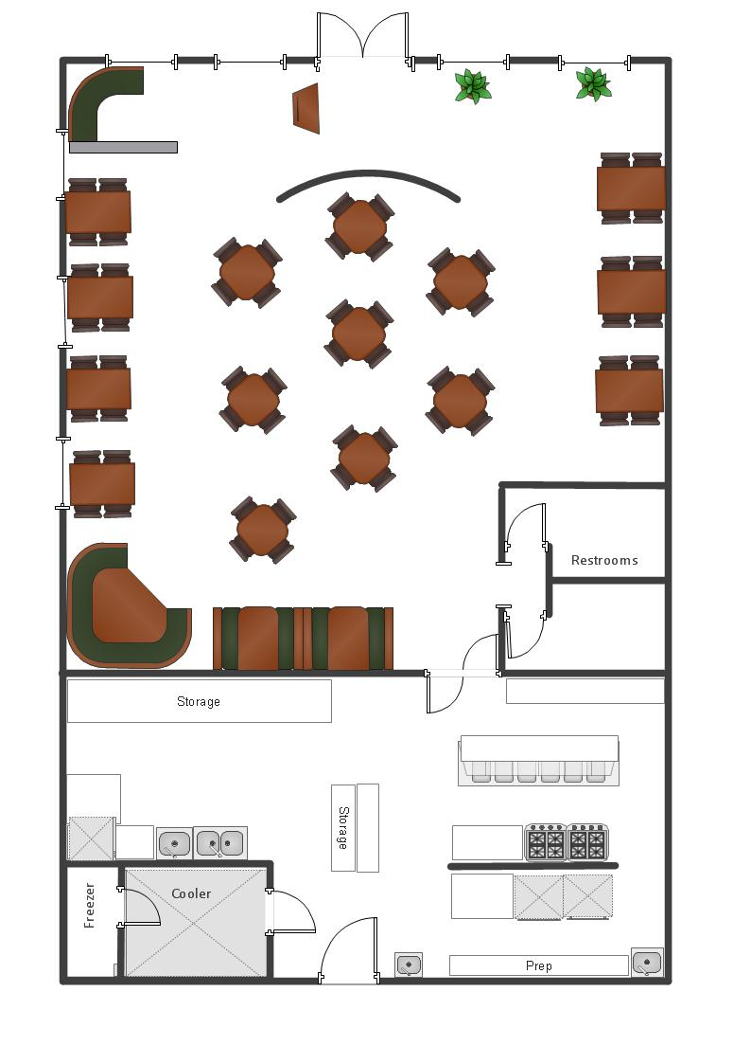
Exhibit E – Management

Sample Organizational Chart

The Organizational Chart below is an example of the positions needed to staff a full- service restaurant with catering functions.


Owner/General Manager

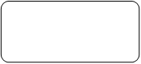
Chef/BOH Manager
FOH Manager
Banquet Manager

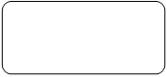
Sous Chef
Server
Banquet Server

Host/Hostess
Banquet Busser


Prep Cook
Busser
Prep Cook
Line Cook

Dishwasher

Exhibit F – Management
Menu Item Clarification

The intent is for teams to develop a menu featuring only twelve menu items. This may be treated as a representative sample that is reflective of the concept’s broader menu. Please see the information below on what constitutes a menu item.

Menu Item Clarification
The general rule of thumb for what counts as a menu item is that anything that is packaged together for one price counts as one item. Please see the examples below for further clarification.

An exception to this rule is a table d’hote menu (see Foundations of Restaurant Management & Culinary Arts Level 2, pgs. 473-74) or prix fixe menu. In those cases, each dish that makes up the table d’hote or choice for prix fixe counts as one menu item.

On the sample menu below, there are examples of how to count menu items.
- Each Appetizer and Salad counts as one menu item
- Each Sandwich counts as one menu item, the costing for each item would include the costliest of the side choices
- Each Dinner item counts as one menu item, costing would include all sides and sauces
- Each Dessert is one item, Each Beverage is one item
- Total menu items count for this menu is: 16
Appetizers |  | Salads
Calamari ¹ | $8.00 | House ³ | $6.50
Fresh, tender squid lightly floured then deep fried, served with lemon wedges and homemade marinara sauce. |  | Spring greens, avocado, roasted peppers, onions, shredded carrots, tomatoes & balsamic dressing
Spinach and Artichoke Dip ² | $7.50 | Crazy ⁴ | $8.50
Warm blend of creamy spinach, tender artichokes, and melted Asiago and Parmesan cheeses. Served with tortilla chips. |  | Chicken breast, goat cheese, spring greens, crushed walnuts, bacon, roasted peppers, onions & balsamic dressing
 |  | Wild Alaska Salmon ⁵ | $10.50
 |  | Alaska salmon, spring greens, tomatoes, sliced lemon & balsamic dressing
Sandwiches  Available with your choice of potato, pasta, or green salad. |  | Entrees
Best Burger ⁶ |  | Pot Roast Dinner ⁹ | $15.75
¼ lb. beef patty, pickle, tomatoes, sautéed onions, spring greens, cheddar cheese | $8.50 | Piled high with cippolini onions, carrots & mushrooms over mashed potatoes, served au jus
Best Chicken ⁷ |  | Chili Glazed Salmon ¹⁰ | $16.50
Chicken breast, spring greens, tomatoes, onions & basil mayo | $8.00 | Served over a roasted vegetable & quinoa pilaf finished with micro greens
Garden Burger ⁸ |  | Chicken Pot Pie ¹¹ | $13.00
Veggie patty, sun-dried tomato pesto, spring greens, avocado, tomatoes, onions, shredded carrot & basil mayo | $7.00 | Roasted chicken in an herbed cream sauce with leeks & carrots under a pastry crust
Desserts |  | Beverages
Cake of the day ¹² | $4.00 | Soda ¹⁴ | $2.00
Ice Cream Sundae ¹³ | $3.50 | Housemade Lemonade ¹⁵ | $2.50
Choice of chocolate or caramel sauce |  | Brewed Coffee ¹⁶ | $1.50
 |  | Regular or decaf

For beverages, each item that is individually priced would count as a menu item. The example below includes 20 items. Note: The Cappuccino and Café Latte, while priced the same, are two separate menu items as they are substantially different items. The Brewed and Iced Coffee are two separate menu items as they are priced differently.

Central Perk Coffee Shop

Item | Small | Medium | Large
Espresso | 1.75¹ | 1.95² | --
Cappuccino | 2.95³ | 3.65⁴ | 3.95⁵
Americano | 2.15⁶ | 2.55⁷ | 2.95⁸
Café Latte | 2.95⁹ | 3.65¹⁰ | 3.95¹¹
Vanilla Latte | 3.45¹² | 4.15¹³ | 4.45¹⁴
Brewed Coffee | 1.95¹⁵ | 2.45¹⁶ | 2.95¹⁷
Iced Coffee | 2.15¹⁸ | 2.65¹⁹ | 3.15²⁰

For a “build your own” concept, ingredients that are individually priced would count as one menu item. The example below includes 9 menu items and are noted in red below.

Bayside Burrito Grille

Item Type  Choose 1 | Protein  Choose 1 | Toppings  Choose 2  ($1 for additional topping)⁵ | Extras
Burrito | Chicken¹ $6.25 | Beans and Rice | Chips and Salsa⁶ $3.00
Bowl | Steak² $6.50 | Cheese | Guacamole⁷ $4.00
Tacos | Ground Beef ³ $5.95 | Salsa | Chips and Guacamole⁸ $6.00
Salad | Vegetarian⁴ $5.75 | Sour Cream | Chips only⁹ $2.00

Note: While a “build your own” concept is permissible, it is recommended that teams instead focus on their core/signature menu of composed items, with an acknowledgement that there are opportunities to “build your own” integrated into the concept’s broader menu.
Exhibit G – Management

Recipe Example

NOTE: For a menu item consisting of Chicken Gruyere served with sautéed spinach, and roasted potatoes, you should include separate recipes for the chicken, the spinach, the potatoes and the sauce.

Management teams must complete this worksheet prior to the competition and include in both the written proposal and costing folder. Portion size is at your discretion.

TEAM NUMBER | 1

Menu Item | Chicken Gruyere
Number of Portions | 4 | Portion Size | 1 breast / approx. 8 oz.
Cooking Method(s) | Sauté, bake
Recipe Source | Chef

Ingredients
Item | Amount
Butter | 2 oz.
Onion, sliced | 8 oz.
Swiss Cheese, shredded | 3 oz.
Bread Crumbs | 3 oz.
Paprika | 1 teaspoon
Chicken Breast, Airline, skinless | 4, approx. 8 oz. each
Salt and Pepper | To taste
White Wine | 3 oz.
Chicken Stock | 3 oz.

Procedure
1. Sauté onions and ½ butter until soft but not brown.
2. Combine cheese, bread crumbs and paprika
3. Sprinkle chicken breasts with salt and pepper

Remainder of procedures…

Exhibit H – Management

Recipe Cost Example

NOTE: For a menu item consisting of Chicken Gruyere served with sautéed spinach, and roasted potatoes, you should include separate recipe costing sheets for the chicken, the spinach, the potatoes, and the sauce.

Management teams must complete this worksheet prior to the competition and include in both the written proposal and costing folder.

TEAM NUMBER | 1
Menu Item | Chicken Gruyere
Number of Portions | 4 | Portion Size | 1 breast/ approx.8 oz.

Ingredient | Purchase Unit | Purchase cost | Unit cost | Amount Needed | Ingredient Cost
Butter | 1 pound | $4.59 | $0.287/oz. | 2 oz. | $0.574
Onion | 3 lbs. | $1.98 | $0.041/oz. | 8 oz. | $0.328
Swiss Cheese | 1 pound | $5.99 | $0.374/oz. | 3 oz. | $1.122
Bread Crumbs | 15 oz. | $1.75 | $0.117/oz. | 3 oz. | $0.351
Paprika | 2 oz. / 12 tsp | $1.79 | $0.895/oz. | .167 oz./1 tsp | $0.149
Chicken Breast | 1 pound | $1.98 | $1.98/# | 2 # | $3.96
White Wine | 750 ml / 25.4 oz. | $12.00 | $0.472/oz. | 3 oz. | $1.416
Chicken Stock | 1 gallon | $6.00 | $0.047/oz. | 3 oz. | $0.141

Subtotal | $8.041
1 % for small amounts of spices (Q Factor) | $0.08
Total Recipe Cost | $8.121
Portion Cost | $2.03

Exhibit I – Management

Menu Price Example

NOTE: For a menu item consisting of Chicken Gruyere served with sautéed spinach, and roasted potatoes, you should include one (1) menu price sheet for the completed menu item.

Management teams must complete this worksheet prior to the competition and include in both the written proposal and costing folder.

TEAM NUMBER | 1

Menu Category | - Starter | X Entree | - Dessert

Recipe | Portion Cost
Chicken Gruyere | $2.03
Sauteed Spinach (from additional recipe and costing sheets) | $0.753
Roasted Potatoes (from additional recipe and costing sheets) | $0.961
Sauce (from additional recipe and costing sheets) | $0.354

Total Plate Portion Cost | $4.098
Menu Price at 33% Food Cost | $12.418
Actual Price on Menu | $12.50

Exhibit J – Management

Marketing Tactic Clarification

Teams must include two marketing tactics as a part of their presentation. The below categories, taken directly from the curriculum, will help identify what qualifies as a marketing tactic and what can be specific examples of each tactic.

Website and social media presence are not tactics in and of themselves. For example, Sprinkles Cupcakes uses twitter for a “whisper words” promotion. Each day a “whisper word” is announced via the official Sprinkles twitter account, and the first 50 patrons to whisper the word of the day receive a free cupcake. In this example, twitter is a vehicle for the promotion. The promotion is sample/free product.

Advertising – Paying to present or promote an operation’s products, services, or identity.
- Newspaper
- Radio
- Magazine
- Billboard
- Metro Transit
- Digital advertisements on social media
Promotions – Incentives to entice customers to patronize an operation.
- Frequent shopper program
- Special Pricing
- Special Events
- Samples
- Contest/sweepstakes
- Signage & display materials
- Merchandising
- Carryout & door hanger menu

Public Relations – The process by which an operation interacts with the community at large.
- Hosting a charity event
- Press release
- Sponsoring a team or event
Direct Marketing – Making a concerted effort to connect directly with a certain segment of the market.
- Post Card mailing campaign
- E-mail campaign
- Deal of the Day website (Groupon, Living Social, etc.)
- Smart phone application that updates and informs customers directly
- Flyers
Exhibit K – Management

Sample Critical Thinking Scenarios

SOCIAL MEDIA

A guest leaves a negative comment of your restaurant on a popular restaurant review website. How would you handle?

Someone posts a bad comment on your restaurant’s Facebook page – what should you do?

SAFETY & SANITATION

While pulling out the beef for your signature ribeye, your prep cook notices that the walk-in seems a bit warm. What do you do?

While cutting lemon wedges for iced teas, your server finds a moldy lemon halfway through the box of lemons. What should the server do?

We see that you have a line cook position. While the line cook is carrying your signature soup, he slips in a puddle of water by the dish area. What do you do?

CUSTOMER SERVICE

A reservation for a party of 4 is showing up in your system as cancelled, yet they have arrived and checked in – what will you tell them?

A guest chokes on a toothpick on their way out the door - what do you do?

HUMAN RESOURCES & STAFFING

One of your employees reports that he is being bullied by another employee. How would you address this? Who would you speak to first?

A guest calls the day after dining and complains that the server added an extra $5 to the tip the guest left. How do you address this?

MARKETING

In the coupon you printed in the newspaper, you forgot to put an expiration date. Two months later, a table presents it for redemption- what do you do?

MENU DEVELOPMENT AND DESIGN

You don’t sell as much of the filet as you anticipated on Friday night, what will you do with the extra filets?

A guest at your steakhouse is a vegetarian – what can you serve him/her?

CONCEPT KNOWLEDGE

Due to your location you serve a high volume during lunch. However, dinner tickets are down. What can you do to increase dinner volume?
- A restaurant very similar to yours opens up across the street – how do you compete?
Exhibit L – Management

Sample Management Competition Timeline

NOTE: The exact order of which category will be judged will vary for each team depending on where the judges start. The order will be announced once the competition schedule is set.

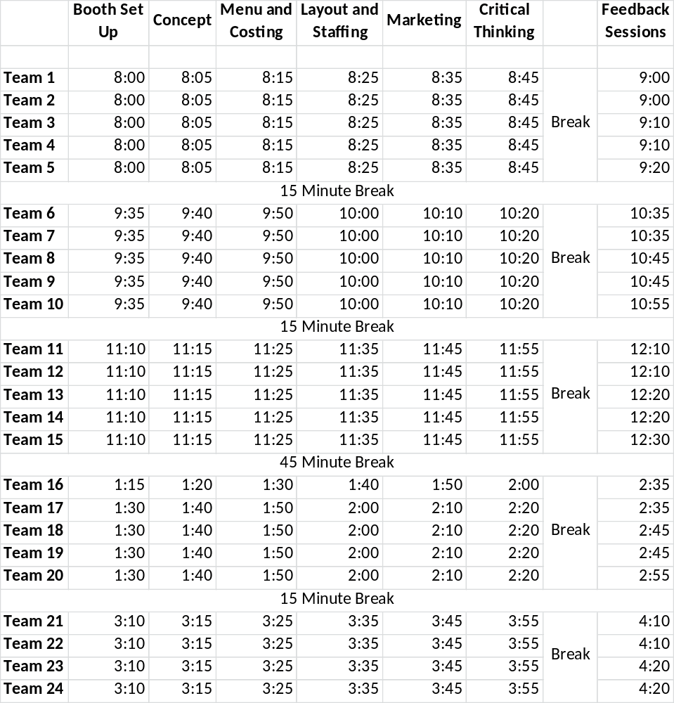
Exhibit M – Management

Sample Management Competition Score Sheet
EVALUATION CRITERIA | POOR | FAIR | GOOD | VERY GOOD | EXCELLENT | SCORE
Concept (30 points)
Description of Concept | 1 2 | 3 4 | 5 6 | 7 8 | 9 10
SWOT Analysis | 1 2 | 3 4 | 5 6 | 7 8 | 9 10
Presentation Skills | 1 | 2 | 3 | 4 | 5
Q & A- Depth of Knowledge | 1 | 2 | 3 | 4 | 5
Menu and Costing (35 points)
Menu Matches Concept | 1 | 2 | 3 | 4 | 5
Description of 12 items | 1 | 2 | 3 | 4 | 5
Sample of how presented | 1 | 2 | 3 | 4 | 5
Photo | 1 | 2 | 3 | 4 | 5
Presentation Skills | 1 | 2 | 3 | 4 | 5
Q & A- Depth of Knowledge | 1 | 2 | 3 | 4 | 5
Menu Poster | 1 | 2 | 3 | 4 | 5
Marketing (40 points)
Matches Concept | 1 | 2 | 3 | 4 | 5
ROI | 1 | 2 | 3 | 4 | 5
Tactic Budgets | 1 | 2 | 3 | 4 | 5
Samples | 1 | 2 | 3 | 4 | 5
Creativity | 1 | 2 | 3 | 4 | 5
Presentation Skills | 1 | 2 | 3 | 4 | 5
Q & A- Depth of Knowledge | 1 | 2 | 3 | 4 | 5
Marketing Poster | 1 | 2 | 3 | 4 | 5
Critical Thinking (55 points)
Teamwork | 1 | 2 | 3 | 4 | 5
Presentation Skills | 1 | 2 | 3 | 4 | 5
Q & A- Depth of Knowledge | 1 | 2 | 3 | 4 | 5
Category 1 | 1 2 | 3 4 | 5 6 | 7 8 | 9 10
Category 2 | 1 2 | 3 4 | 5 6 | 7 8 | 9 10
Category 3 | 1 2 | 3 4 | 5 6 | 7 8 | 9 10
Category 4 | 1 2 | 3 4 | 5 6 | 7 8 | 9 10
Operations (30 points)
Layout Selection & Floorplan | 1 2 | 3 4 | 5 6 | 7 8 | 10
Interior and décor | 1 | 2 | 3 | 4 | 5
Organizational chart | 1 | 2 | 3 | 4 | 5
Presentation Skills | 1 | 2 | 3 | 4 | 5
Q & A- Depth of Knowledge | 1 | 2 | 3 | 4 | 5
Menu and Costing (5 points)
Recipes, Costing, Pricing | 1 | 2 | 3 | 4 | 5
DISQUALIFICATION | PENALTY
Reason for Disqualification: | Reason for Penalty:
_____ Team missed appointed time to compete. | _____ Team uniform does not fit competition guidelines. 5 points.
_____ Team received coaching/communication while competing. | _____ Restaurant concept not located in ProStartville OR does not match provided restaurant space scenarios. 5 points.
_____ Team used parts of a previously submitted team’s work | _____ Menu includes more or less than 12 menu items. 5 points.
_____ Team did not compete in each event segment (written, verbal, critical thinking) | _____ Includes food costing worksheets for more or fewer than 1 menu item. 5 points.
 | _____ Includes more or less than 1 menu pricing worksheet. 5 points.
 | _____ Includes more or less than 2 marketing tactics. 5 points.
 | _____ Written proposal prepared incorrectly. 5 points.
 | _____ All 15 written proposal copies are not identical. 5 points.
 | _____ Team includes an alcoholic beverage as one of their menu items. 5 points.
 | _____ Team uses an alcohol-related activity or promotion as one of their marketing tactics. 5 points.
 | _____ Team does not use one of the four FRLAEF provided restaurant space scenarios. 5 points.
 | ______ Posters do not meet specifications or include additional information. 5 points.

