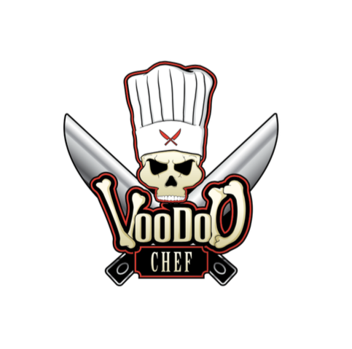
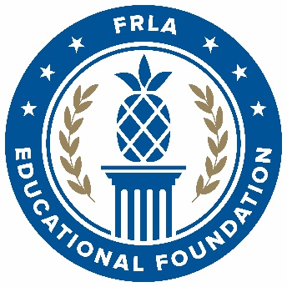
Sixth Annual
VooDoo Chef
Recipe Challenge

Presented by:
Keiser University


Powered by:
The United States Coast Guard
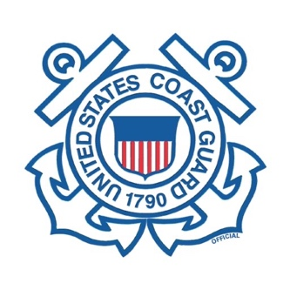

Mission: NOLA
Commitment Date: December 15, 2021
Seasoning Mail Out Date: January 1, 2022
Recipe Submission Date: February 11, 2022
Winners Announced: March 6, 2022

VooDoo Chef High School Recipe Challenge

Eligibility
All participating students must be Seniors enrolled in a high school culinary program using the ProStart® curriculum during the 2021 – 2022 school year.

Purpose
Participating students will demonstrate their culinary knowledge, skills, and creative abilities through the creation of an original recipe. The entrée recipe entered will consist of a protein (such as meat, fish, or fowl), a vegetable, and a starch. Participation will reinforce the skills and knowledge learned from the ProStart curriculum.

General Competition Rules
- Participant, through their instructor, will commit to participate no later than December 15, 2021, by filling out the commitment form at the following link: www.VooDooChef.com
- Each participant will be provided with a sample of VooDoo Chef NOLA. Product will be sent to participants via their instructor.
- Multiple students from each school may enter. Each student entering will receive their own portion of the product.
- Each participating student may only enter one time.
- Mentors can assist student in preparing for the competition. However, they cannot prepare the menu. Their expertise is limited to menu suggestions and technique advice.
- Each participating student’s entrée recipe must consist of a protein, vegetable, and starch. The portion sizes for each meal should be a single serving. Suggested serving sizes are 4-6 ounces for protein, 2-3 ounces for starch and 2-3 ounces for vegetables. The recipe must incorporate VooDoo Chef NOLA into the protein portion of the plate.
- Each participating student’s recipe should utilize a minimum of two cooking methods from the following list: Poach, Shallow Poach, Braise, Pan Fry, Steam, and Sauté. Students are allowed to use additional techniques if they so desire.
- Final recipes and photos should be received no later than February 11, 2022. All entrees must be submitted electronically to HighSchoolRecipeContest@VooDooChef.com.

Menu and Recipe Presentation
- Participating entrants must submit Entry Form, Typed Recipes, and Photos electronically to Let’s Do Gourmet at HighSchoolRecipeContest@VooDooChef.com.
- All recipes and photos submitted will become the property of Let’s Do Gourmet, LLC (owner of the VooDoo Chef brand) and will not be returned. By participating in the VooDoo Chef High School Recipe Challenge, you are agreeing to allow Let’s Do Gourmet, LLC to post and publish your recipes and photos.
- Photos must be in color, and may be submitted electronically via email. We encourage all participants to post photos of their creations onto the VooDoo Chef Social Media Pages. Facebook www.facebook.com/voodoochef13 Twitter & Instagram: @VooDooChef13. We also encourage entrants to use the Hashtags #VooDies when posting.

Awards
- Let’s Do Gourmet, LLC, Keiser University, and US Coast Gaurd representatives will judge all submissions.
- The first-place winner will receive a
  - Let’s Do Gourmet gift basket with prizes to be determined.
  - Scholarship to Keiser University
- Winners will be announced on March 6, 2022.

VooDoo Chef
Sixth Annual
High School Recipe Challenge

Mission: NOLA

Entry Form

Student Last Name |  |  |  | Student First Name |  |  |  |  | MI |  |  | Cell Contact
School Name |  |  |  |  |  |  | Student Email Address
School Address |  |  |  |  |  |  | Instructors Last Name |  |  |  |  |  |  |  | Instructors First Name
City, State, Address |  |  |  |  |  |  | Instructor Contact Number
School Phone Number |  |  |  |  |  |  | Instructor Email

All entrants and instructors must read the following and sign.
I understand that the recipes and photos I am submitting to the VooDoo Chef High School Recipe Challenge may be used for marketing purposes. I understand the recipes and/or photos entered in this competition may be published online, in magazines, or in other media sources as part of Let’s Do Gourmet, LLC marketing campaign.

Student Signature |  | Date
Teacher Signature |  | Date

Recipe Example

Contestant Name

School Name

Educator Name

Menu Item
Number of Portions |  | Portion Size
Cooking Method(s)
Recipe Source

Ingredients
Item | Amount
Procedure

Checklist
- Completed entry form
- Recipe; typed in official format.
- Plate Photograph

VooDoo Chef High School Recipe Challenge

Scoring Rubric

Contestant
School

The following score sheet should be used to evaluate each contestant based on their use of the recipe, ingredients and cookware provided. Please circle the number that most closely corresponds with your assessment of the contestant’s performance.

Submission – 10%
1. | All:  - Recipe submitted on proper form  - Photo Included  - Use of VooDoo Chef NOLA  - Uses a minimum of two cooking methods | Y (2) N (0)
Plate/Appearance –25%
1. | Including but not limited to:  - Plate consists of a Protein, Starch, and a Vegetable  - Proper portion size  - Balance of color  - Shape  - Texture | 1 2 3 4 5
Appearance Total
Taste – 40%
1. | A subjective category based on tasting judges’ expertise | 2 4 6 8
Taste Total
Originality – 25%
2. | The contestant uses artistic, creative or imaginative ingredients. | 1 2 3 4 5
Originality Total
Total:
 | Overall – 20 Possible

