The Blue Zones
The concept of “blue zones” grew out of the demographic work done by Gianni Pes and Michel Poulain outlined in the Journal of Experimental Gerontology, identifying Sardinia as the region of the world with the highest concentration of male centenarians. Pes and Poulain drew concentric blue circles on the map highlighting these villages of extreme longevity and began to refer to this area inside the circle as the blue zone. Building on that demographic work, Dan Buettner pinpointed other longevity hotspots around the world and dubbed them blue zones. Blue Zones® is now a trademark of Blue Zones, LLC, and reflects the lifestyle and the environment of the world’s longest-lived people.
Dan Buettner, Blue Zones founder, is a National Geographic Fellow and multiple New York Times bestselling author. He has discovered five places in the world – dubbed blue zones – where people live the longest, and are healthiest: Okinawa, Japan; Sardinia, Italy; Nicoya, Costa Rica; Ikaria, Greece, and Loma Linda, California.
We found five places that met our criteria:
- Barbagia region of Sardinia – Mountainous highlands of inner Sardinia with the world’s highest concentration of male centenarians.
- Ikaria, Greece – Aegean Island with one of the world’s lowest rates of middle age mortality and the lowest rates of dementia.
- Nicoya Peninsula, Costa Rica – World’s lowest rates of middle age mortality, second highest concentration of male centenarians.
- Seventh Day Adventists – Highest concentration is around Loma Linda, California. They live 10 years longer than their North American counterparts.
- Okinawa, Japan – Females over 70 are the longest-lived population in the world.
We then assembled a team of medical researchers, anthropologists, demographers, and epidemiologists to search for evidence-based common denominators among all places. We found nine.

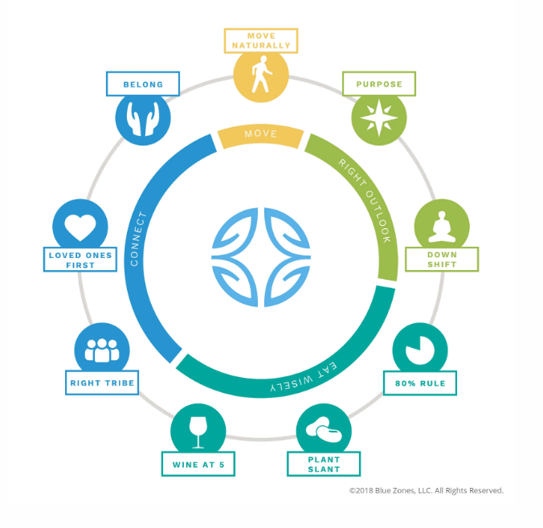

Blue Zones Power 9: Lifestyle Habits of the World’s Healthiest, Longest-Lived People

1. Move Naturally
The world’s longest-lived people don’t pump iron, run marathons or join gyms. Instead, they live in environments that constantly nudge them into moving without thinking about it. They grow gardens and don’t have mechanical conveniences for house and yard work.

2. Purpose
The Okinawans call it “Ikigai” and the Nicoyans call it “plan de vida;” for both it translates to “why I wake up in the morning.” Knowing your sense of purpose is worth up to seven years of extra life expectancy

3. Down Shift
Even people in the Blue Zones experience stress. Stress leads to chronic inflammation, associated with every major age-related disease. What the world’s longest-lived people have that we don’t are routines to shed that stress. Okinawans take a few moments each day to remember their ancestors, Adventists pray, Ikarians take a nap and Sardinians do happy hour.

4. 80% Rule
“Hara hachi bu” – the Okinawan, 2500-year old Confucian mantra said before meals reminds them to stop eating when their stomachs are 80 percent full. The 20% gap between not being hungry and feeling full could be the difference between losing weight or gaining it. People in the blue zones eat their smallest meal in the late afternoon or early evening and then they don’t eat any more the rest of the day.

5. Plant Slant
Beans, including fava, black, soy and lentils, are the cornerstone of most centenarian diets. Meat—mostly pork—is eaten on average only five times per month. Serving sizes are 3-4 oz., about the size of a deck of cards.

6. Wine @ 5
People in all blue zones (except Adventists) drink alcohol moderately and regularly. Moderate drinkers outlive non-drinkers. The trick is to drink 1-2 glasses per day (preferably Sardinian Cannonau wine), with friends and/or with food. And no, you can’t save up all week and have 14 drinks on Saturday.

7. Belong
All but five of the 263 centenarians we interviewed belonged to some faith-based community. Denomination doesn’t seem to matter. Research shows that attending faith-based services four times per month will add 4-14 years of life expectancy.

8. Loved Ones First
Successful centenarians in the blue zones put their families first. This means keeping aging parents and grandparents nearby or in the home (It lowers disease and mortality rates of children in the home too.). They commit to a life partner (which can add up to 3 years of life expectancy) and invest in their children with time and love (They’ll be more likely to care for you when the time comes).

9. Right Tribe
The world’s longest lived people chose–or were born into–social circles that supported healthy behaviors, Okinawans created ”moais”–groups of five friends that committed to each other for life. Research from the Framingham Studies shows that smoking, obesity, happiness, and even loneliness are contagious. So the social networks of long-lived people have favorably shaped their health behaviors.
To make it to age 100, you have to have won the genetic lottery. But most of us have the capacity to make it well into our early 90’s and largely without chronic disease. As the Adventists demonstrate, the average person’s life expectancy could increase by 10-12 years by adopting a Blue Zones lifestyle.
Blue Zones Activity
- After watching Ted Talk Blue zones, bring students to computer lab.
https://www.ted.com/talks/dan_buettner_how_to_live_to_be_1000

- Click on Blue zones Longevity test and follow links to complete.
https://www.bluezones.com/#section-1

- Right Menu Click on True Vitality Test
- Copy and paste detailed results from email to word document.
- Print.
- Write your name on top and your current age.
- Circle the 3 recommendations that you can begin to help improve your healthy longevity.
- Place a star next to the one you think is most important to improve your life.
- Turn in to Chef to tabulate results.
- Share with the class the #1 suggestion that you starred.
- You may also complete the True Happiness Test found in the same location.

