ProStart Teachers
2022

International
Desserts

Snowy Moon Cake

Snow skin mooncake, snowy mooncake, ice skin mooncake or crystal mooncake is a Chinese food eaten during the Mid-Autumn Festival. Snow skin mooncakes are non-baked and originate from Hong Kong. Most often they are made with a creamy custard filling, but other fillings such as sweet red bean paste are common as well.
There are many varieties of moon cakes. Baked moon cakes consist of thick, tender, tart dough-like wrappers and may be sweet or savory.

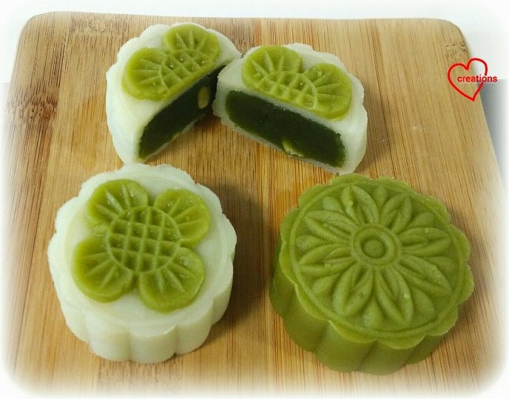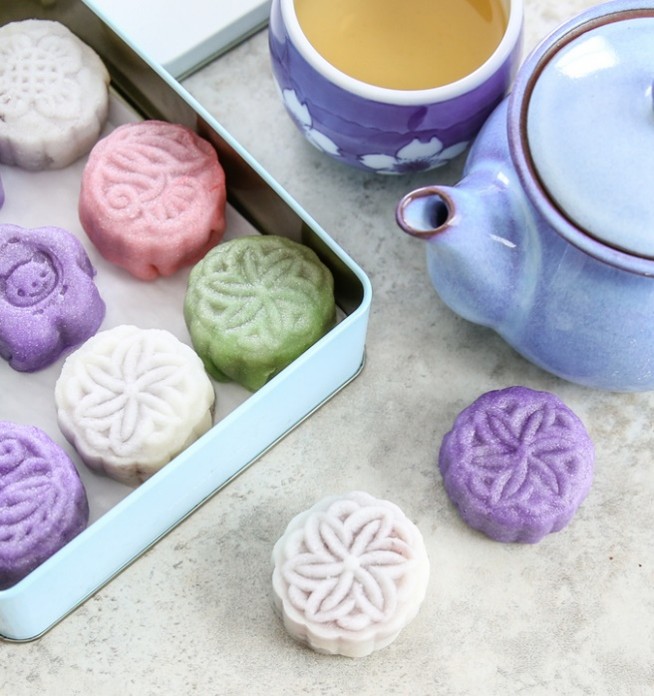

INGREDIENTS:
- 6 tbsp glutinous rice flour
- 6 tbsp rice flour
- 4 tbsp wheat starch or cornstarch
- 6 tbsp icing sugar (confectioners’ sugar) sifted
- 1 cup milk
- 2 tbsp condensed milk
- 2 tbsp cooking oil

- 1 package or 1 can of sweet red bean (adzuki bean) paste. Thicken with cornstarch as necessary. There are many recipes online for making sweet red bean paste from scratch.

- If using canned red bean paste that are whole beans, puree beans in a food processor then add 3 tablespoons of cornstarch per can and cook until boiling and thick. Spread onto a sheet pan and cool until firm, preferably overnight.

INSTRUCTIONS

SKIN:

- Create a double boiler with a pot of water and a bowl.
- In the bowl, whisk all the ingredients, except the red bean paste, until well combined.
- Steam over the double boiler, without stirring, for 20 – 30 minutes until the mixture is completely coagulated.
- Scrape the hardened dough out of the bowl. When cool enough to touch, knead with hands (using gloves to prevent sticking) until smooth and elastic.
- Divide the dough into 3 120-gram pieces. Leave one piece white and color the other pieces: Add matcha powder (for green)/purple sweet potato powder (for purple) directly to the steamed dough then knead well to evenly distribute the color, add little by little until the desired color appears, 1-2 teaspoons. (Food color can also be used.)
- Divide each piece into 6 20-gram pieces, round and flatten into a disc, wrap and refrigerate for 30 minutes to overnight.

FILLING:

- Portion the filling into 20-gram pieces. Round each piece, cover and refrigerate until ready to use.

TO ASSEMBLE:

- Make a 50/50 mixture of rice flour and cornstarch. Use this to dust you fingers and pastes as needed. Careful not to use too much as the dough needs to be sticky to hold together.
- With your fingers, flatten a piece of dough to an approximate 3” disc keeping the center a little thick.
- Place a ball of filling in the middle. Gently push the wrapper upwards and pinch to seal completely.
- Dip into the 50/50 mix and roll it into a ball.
- Shape this into a cylinder then carefully place it into the mold. Place it on a worksurface and gently push down to imprint the pattern then push the cake out of the mold.

Eat immediately or cover and refrigerate.

Notes:

If you don’t have mooncake molds, you can just eat them without molding them. Since we are celebrating the mid-autumn festival, it is always nice to add a sense of ceremony to this dessert.

Moon cake molds come in gram sizes. Since we are portioning 20 grams for the wrappers and 20-30 grams for the filling, we are using 50-gram molds.

Moon cake molds can be purchased in sets online for $10 to $15.

Pasteles De Platano (Plantain Pastries)
A traditional Salvadoran sweet often made and sold by street vendors.

Yields About 15

• 1 pound ripe plantains, deveined and boiled until soft
• 1/8-1/4 cup granulated sugar
• Cinnamon to taste
• Pastry cream, see below
• Nutmeg, as needed
• Granulated sugar, as needed

1. Mash the cooked plantain with cinnamon and a little sugar.
2. Using a #30 scoop, portion out plantains and press this into rounds.
3. Fill with pastry cream and seal (like an empanada). Dust with nutmeg.
4. Fry until golden, drain on paper towels, then roll in sugar.

Pastry Cream (1x per rotation)

• 1 quart milk
• 8 ounces sugar
• 3 ounces corn starch
• 3 eggs

1. Combine half of the sugar with milk in a pot; bring to a boil over medium heat.
2. In a bowl, mix together the corn starch, remaining sugar, and eggs.
3. Temper the two mixtures: pour half of the milk into the egg mixture mixing well with a whisk. Pour everything back into the saucepan with the remaining boiling milk.
4. Over medium heat bring this mixture back to boil mixing constantly. Boil for 2 minutes mixing constantly in order to cook the starch properly.
5. Strain.
6. When cool, beat the custard to bring it back to a creamy texture if needed.



Pouding Chômeur À L'érable
Unemployed man's pudding. This classic Québécois maple pudding is rich in flavor, easy to make, and utterly comforting.

Prep Time:15 mins
Cook Time:45 mins
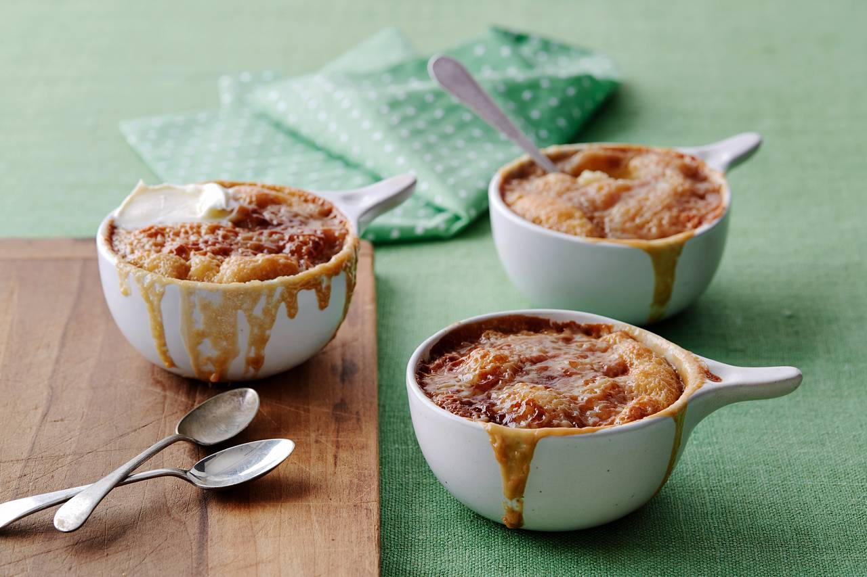
Total Time:1 hr
Servings10 servings

Ingredients

For the sauce, maple version
• 1 ½ cups pure maple syrup
• 1 ½ cups heavy whipping cream
• ½ tsp kosher salt, or fine sea salt

For the cake
• 1 ½ cups all-purpose flour
• 2 tsp baking powder
• ½ tsp kosher salt, or fine sea salt
• ½ cup unsalted butter, softened
• 1 cup granulated sugar
• 2 eggs
• ¾ cup milk
• 1 tsp pure vanilla extract

Preheat the oven to 400°F (200°C).
Butter a 9 x 13-in (23 cm x 33 cm) baking pan.

For the sauce:

1. In a saucepan, whisk the maple syrup and heavy cream (or the brown sugar, water, and flour) together. Bring to a boil, whisking occasionally.

For the cake:
1. In a small bowl, mix the flour, baking powder, and salt together. Set aside. Measure the milk in a cup and mix in the vanilla extract. Set aside.

2. In the bowl of a stand mixer, or in a large mixing bowl if using a hand mixer, beat the butter and sugar together until fluffy. Mix in the eggs one at a time, beating well after adding each one. With the beater on low speed, mix in half of the dry ingredients, then mix in the milk, and finally add the remaining dry ingredients, mixing just until combined. Pour the mix into the prepared pan.

3. Pour the maple syrup sauce over the batter.

4. Set the baking dish over a baking sheet to prevent spills. Bake the maple pudding for about 45 minutes, or until the top is golden brown and the sauce is bubbly.
Kashata

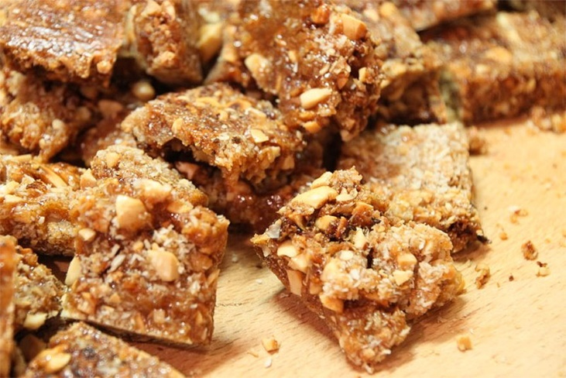 Kashata is a spiced peanut , coconut, and sugar candy that is a very popular Swahili treat, sold and enjoyed in most parts of Eastern Africa (Tanzania, Kenyan, Uganda). It is sometimes found in other parts of Africa where there is a Muslim community.

Prep Time10 minutes
Cook Time15 minutes
Total Time25 minutes
Servings12 -14 slices

Ingredients

• 2 cups roasted peanuts shells and skin peeled lightly chopped
• ½ cup coconut milk water
• ½ cup coconut flakes optional
• 1/2 teaspoon of each cardamom, cinnamon, nutmeg spice
• 1 ¾ cup sugar
• ½ teaspoon salt

Instructions

1. Spray about an 8-inch baking pan with cooking spray. Set aside
2. In a large heavy sauce- pan combine granulated sugar, coconut milk, cardamom and salt.
3. Cook over medium high heat, stirring until all the sugar has dissolved. Stop stirring when the sugar has dissolved. You may swirl pan to prevent mixture from burning. (Stirring helps form crystallization which you do not want during this process)
4. Continue to cook, until mixture thickens and sugar just starts to caramelize- about 10 minutes or more depending on stove You may use a spoon to check for thickness.
5. Finally add peanuts and coconut, quickly mix until all the ingredients have been fully combined . Remove immediately and spread mixture onto prepared pan.
6. Let it cool completely and firms up, then use a sharp knife to break into pieces. Store in airtight container.

