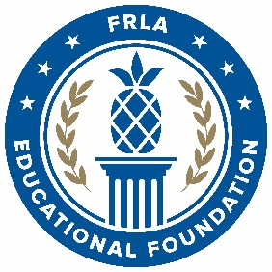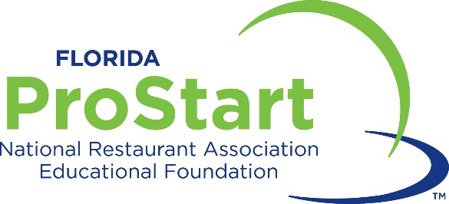

Participant Waiver and Release

I (we) understand that I (we) hold Florida Restaurant & Lodging Association Educational Foundation (FRLAEF) and any affiliated entity, including its officers, agents and employees harmless from any and all liability or claims, which may arise out of or in connection with my child's participation in the Florida ProStart Culinary Team Competitions, to be held on March 4-5, 2023 at the Rosen Plaza Hotel in Orlando, and related and surrounding activities, including but not limited to mandatory or optional events or tours (collectively “the event”). I (we) fully understand that participants are to abide by all rules and regulations governing conduct during the trip. Any violation of these rules and regulations may result in that individual being sent home at the expense of his/her own and/or parent/guardian.

The Foundation is taking reasonable good-faith efforts to protect the health and safety of all participants. However, complete elimination of risk of exposure or infection to COVID-19 and other infectious diseases is not currently possible. Therefore, by attending the event, all participants and guests assume the risk and liability for any exposure to COVID-19 or other infectious diseases and any related loss, liability, or injury sustained at the event at all times.

You agree to comply with all state, local and facility rules, regulations and laws, any rules set by the FRLAEF, and Code of Conduct
described below. You acknowledge and agree that the FRLAEF will enforce the Code of Conduct and all other rules throughout the
event, and that the FRLAEF reserves the right to remove you from the event if, the FRLAEF, in its sole discretion, determines that your
presence or behavior creates a disruption or otherwise hinders the event or the enjoyment of the event by other attendees. You
acknowledge and agree that if you or any member of your team is removed due to your conduct, your team may be declared
ineligible to compete, as determined by the FRLAEF in its sole discretion. The Code of Conduct may be revised at any time by the
FRLAEF and the terms are non-negotiable. Your registration for and/or attendance at the event indicates your agreement to abide by
the following Code of Conduct:
- Expected Behavior. All attendees are expected to behave in accordance with the standards listed within this Code of Conduct, the policies from their respective school, employer, the FRLAEF’s policies governing appropriate school and workplace behavior, and all applicable laws and regulations.
- Misconduct. Attendee misconduct, whether onsite or offsite, will not be tolerated. Any report of misconduct will be addressed immediately. Attendees asked to stop any misconduct are expected to comply. Anyone who witnesses or is subjected to any of the above behaviors, or any behavior that makes them feel unsafe, should notify event staff at once. Examples of unacceptable behaviors include:
  - Unsportsmanlike conduct, including but not limited to –
    - Harassment based on gender, gender identity or expression, sexual orientation, ability or disability, physical appearance, race, age, religion, body size, or any other status.
    - Use of abusive, offensive, sexualized, or degrading language, gestures, or physical contact.
    - Taunting, booing, or other verbal assaults designed to provoke animosity between competitors or distract active teams during competition.
    - Intimidation of or unwelcome advances toward other attendees.
    - Slander or libel of any attendee, whether group or individual, on a public or private forum, including but not limited to, social media platforms, online posts, or other forms of communication, whether occurring before, during or after the event.
  - Cheating, including but not limited to –
    - Communication or coaching between competing teams and any non-competing attendee from team report time through dismissal.
    - Ineligible persons participating as a competition team member.
    - Use of previously submitted work.
    - Plagiarism or copying of any kind.
  - Nonprescription drug use, alcohol use, or other illicit substance use.
  - Threats or acts of violence of any kind.
  - Possession or display of weapons onsite.
  - Failure to comply with health and safety protocols.
  - Reckless, unsafe, careless, negligent, harmful, or potentially harmful conduct.
- Consequences for Violation of Code of Conduct. If an attendee engages in conduct that violates the terms above, the FRLAEF’s staff may take any action they deem appropriate depending on the circumstances, ranging from issuance of a warning to the offending individual, to expulsion from the event to disqualification of an event competition team, to rescinding or reevaluating competition awards. The FRLAEF reserves the right to exclude any attendee found to be engaging in misconduct from participating in any further FRLAEF events, trainings, awards, programs, or other activities.
- Reporting Violations. If you witness or are subjected to any of the above behaviors, or any behavior that makes you feel unsafe, please contact a member of the event staff immediately. Event staff can be identified by staff badges onsite, and an organizer can be found at the event registration counter at any time. You may also reach out to: laura@frla.org
- Questions. If you are planning to attend the event, and have concerns regarding the above Code of Conduct, please contact our team at laura@frla.org.
Other than to the extent required as a matter of law, neither the FRLAEF nor its affiliates shall be liable for any direct, indirect, special, incidental, or consequential costs, damages or losses arising directly or indirectly from the event or other aspect related thereto or in connection with this Agreement, including any loss of personal property, personal injury or death.

In the unlikely occurrence that the event must be cancelled or postponed due to circumstances beyond the control of the FRLAEF, we
will not be liable to you for any damages, costs, or losses incurred, such as transportation or accommodations costs.

I (we) hereby consent that FRLAEF, its representatives, successors or assigns, shall have the right to publish or use any photographs, movie films, video tapes, digital images and/or sound recordings, submitted text or any part thereof, they have taken or made of me (student) on this date or in which I (student) may have been included, for publicity, advertising, Internet usage or any other lawful purpose in conjunction with my (student) own or a fictitious name or image, or in reproductions thereof in color.

I (we) hereby waive all claims for any compensation for use or for damages.

I (we) hereby waive any right that I (we) may have to inspect and/or approve the finished product or the use to which it may be applied.

I (we) hereby warrant that I (we) have every right to contract in my (student) own name in the above regard. I (we) state further that I (we) have read the above authorization and release, prior to its execution, and that I (we) am fully familiar with the contents thereof.

This form must be completed and signed before students are eligible to participate in the Florida ProStart® Culinary Team Competitions. I (we) have read, understand, and agree to comply with the information in this document.

Name of Student (print)
High School Name
Current Grade Level
Home Address
City, State, Zip
Student Email |  | Telephone
Emergency Contact |  | Telephone
After you graduate, do you plan to study restaurant management or culinary arts? Yes No
Do you plan to pursue a career in the restaurant & food service industry? Yes No
Student Signature |  | Date
Parent/Guardian Name (print)
Parent or Guardian Signature |  | Date

Completed, signed Participant Waivers must be collected by educators and send to the FRLAEF.
Students without a waiver will not be allowed to participate.

